ASSIGNMENT FOR CLASS JKG

CULTURE AND TRADITIONS OF KASHMIR

KANGRI :-Kangri is used to keep people warm in kashmir.

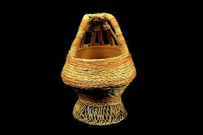

PHERAN:- The traditional dress of kashmir is pheran
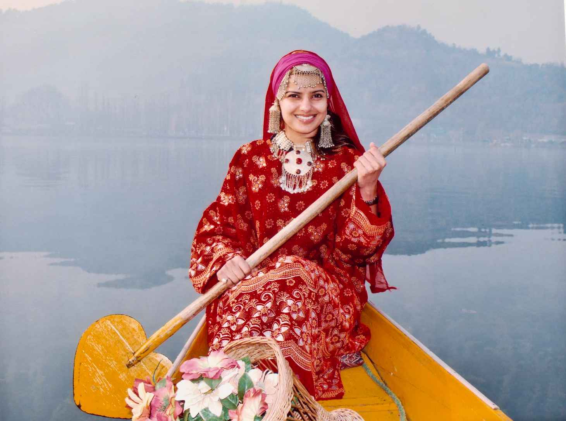

ROUF Rouf is the traditional dance of Kashmir.

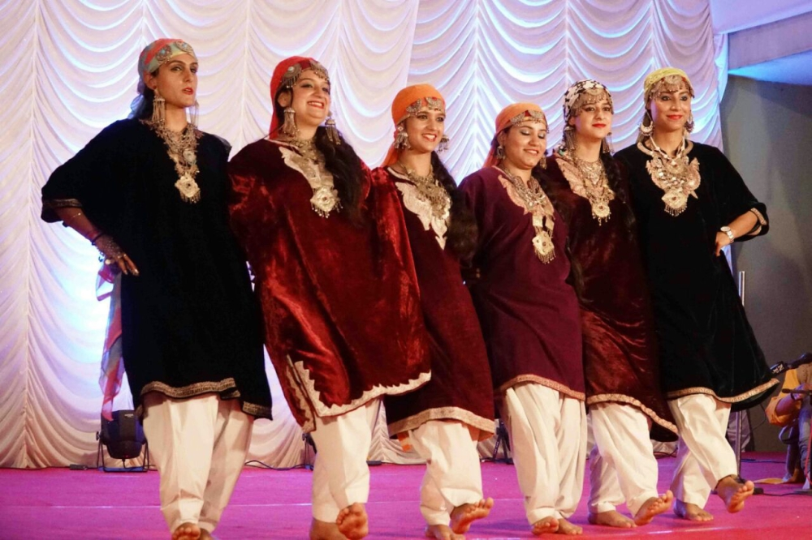

WAZWAN •Wazwan is a multi-course meal in Kashmiri cuisine

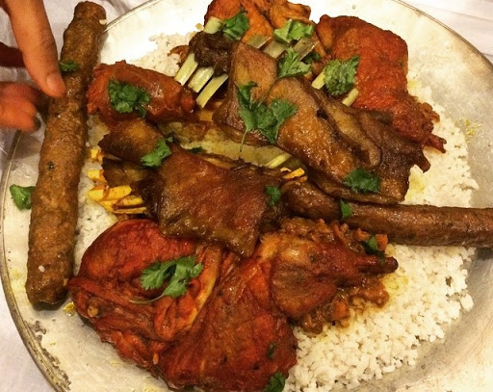

SAMOVAR Samovar is a metal container traditionally used to make kehwa or tea in Kashmir.
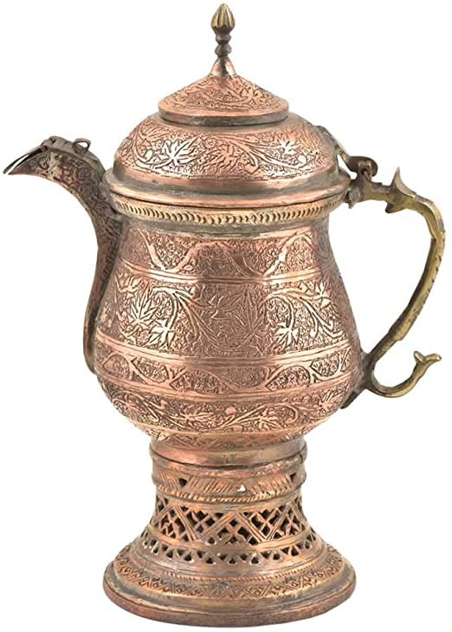

Thank you

