Assignment for Class 3rd

Topic:- Different types of Houses



People all around the world have developed their own methods of building houses. Houses are built to suit the weather or climate and living conditions of that place. Houses are very important to us as they protect us from heat, cold, rain, wind, dust and also, protect us from wild animals and thieves. A house is a place where you feel warm and cozy. You have things around you that are special and have meaning, but most of all you are surrounded by people you love and who love you.

**The houses we live in are not the same everywhere…**

TYPES OF HOUSES

Kachha House

Pakka House

* Some are **Kachha** houses while others are **Pakka** houses.
  + Kachha houses are mostly found in villages. They are made of mud, dry leaves, straw and bamboo. These houses are not strong. They can get damaged easily.
* Pakka houses are found in cities and towns. They are made of bricks, steel and cement. There are different types of pakka houses

**QUESTION/ ANSWERS**

Q1. Name the houses on wheels?

Answer. The houses on wheels are:- (a) Wheel caravan (b) House boat

Q2. Name the house made of ice?

Ans. The house made of ice is called an igloo.

Q3. What is a Kachha house?

Ans. A Kachha house is made of mud, dry leaves, straw and bamboo. A Kachha house is not very strong and is mostly found in villages.

Q4. What is a pakka house?

Ans. A Pakka house is made of bricks, steel and cement. A pakka house is found in towns and cities.

Q5. Why do we need a house?

Ans. We need a house to live in because in it we feel safe and comfortable. It protects us from heat, cold, rain and also from wild animals and thieves.

Topic:- Parts of A Plant

The main parts of a plant include:

* Roots
* Stem
* Leaves
* Flowers
* Fruits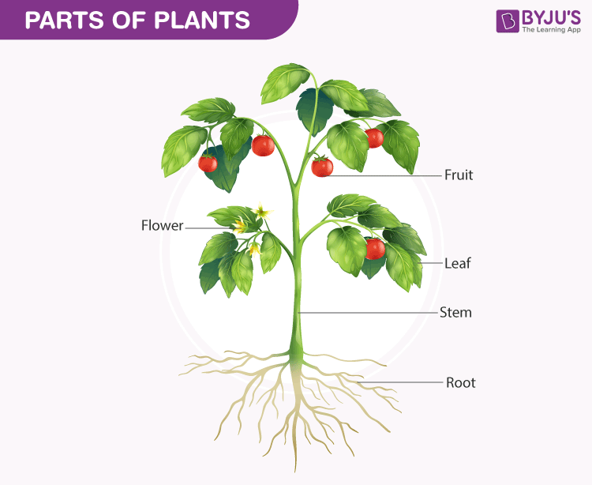

Parts Of Plants Diagram

Roots

Roots are the important and underground part of a plant, which are collectively called the [**root system**](https://byjus.com/biology/root-system/). They are the major part of the plant firmly in the soil. They absorb water and minerals from the soil, synthesis plant growth regulators, and store reserve food material. The apical part of the root is covered by the root cap that protects the root apex.

Stem

The stem is the part of the plant which is found above the ground. The bark of trees are brown in colour and younger stems are green in colour. It forms the basis of the shoot system and bears leaves, fruits and flowers. The stem provides support to the plant.

### Leaves

Leaves are the most important part of a plant. They contain chlorophyll that helps the plants to prepare their food using sunlight, carbon dioxide and water.

Flowers

Flowers are the most beautiful and colourful part of a plant. They are the reproductive part of a plant. A flower has four major parts, namely,

* Petal,   Sepals ,Stamens ,Pistil

### ****Fruits****

Fruits are the main features of a flowering plant.

THE END