ASSIGNMENT FOR TERM IST
Class: - 4th Subject: - EVS
Session: - 2019-2020
Answer the following questions
Q1. Why do we need food?
Ans. We need food to live. It is essential for our growth. It helps us to stay healthy and fit.
Q2. What are the special Occasions?
Ans: - Festivals, weddings and birthdays are special occasions. Special dishes are cooked on these occasions.
Q3. What are chawls?
Ans. Chawls are small congested houses. These houses lack open space.
Q4. What is a map?
Ans. A map is a drawing representing different features of a place.
Q5. What is a stem?
Ans. The part of a plant just above the ground is called a stem.e.g, Potato, Onion and Ginger etc.
Q6. Explain the different parts of a flower?
Ans. Different parts of a flower are:-
- Sepal: - Sepal is the green part of the outermost circle of a flower. It protects the flower when it is a bud.
- Petals: - Petals are found inside the sepal. Petals are the most attractive and colourful part of a flower.
- Stamen: - Stamens are stalks with swollen tops found inside the petals.
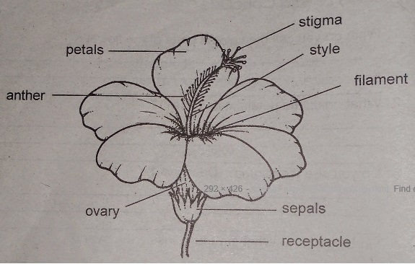

Q2. Fill in the blanks:-
- Laying eggs is also a way of reproduction.
- Our Tongue helps us to swallow the food.
- The heap of garbage is leveled using a bulldozer.
- Growing children need to eat a diet rich in protein.
- Mid-day meal is a free of cost meal.
- A sketch is a rough drawing.
Q3. Match the following
COLUMN A COLUMN B
- Havelis Open space
- Apartment Lack of space
- Slum Congested
- Dog Kennel
- Bungalows Big houses
- Horse Stable.
Q4. Write down ten agricultural products of Jammu and Kashmir.
Ans. 1) Saffron 2) Walnut 3) Almonds 4) Apples 5) Rice
6) Wheat 7) Cotton 8) Barley 9) Maize 10) Pulses.
Q5. States and capitals of India
- Punjab ---------------------- Chandigarh
- UttarPradesh --------------- Lucknow
- Bihar ------------------------- Patna
- Haryana --------------------- Chandigarh
- Assam ----------------------- Dispur
- Madhya Pradesh ----------- Bhopal.

Q6. What is Digestion?
Ans. Digestion is the process by which complex food stuffs are changed into simpler one by the action of enzymes.
ORGANS OF DIGESTION
- Mouth 2) Food pipe 3) Stomach 4) Liver
5) Small Intestine 6) Large Intestine 7) Rectum 8) Anus

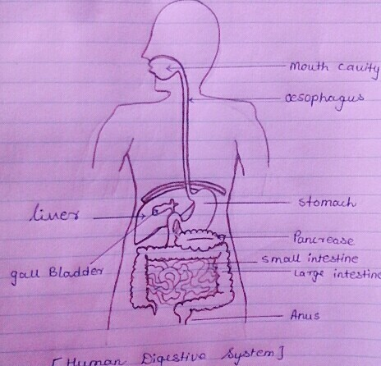

Q7. What is Skeleton? What are its functions?
Ans. Skeleton is the boney framework of our body. It consists of skull, trunk and limbs. It has 26 bones.
FUNCTIONS OF SKELETON
- It protects our internal organs.
- It gives shape to our body.
- It gives support to our body.
- It enables us to move.
- It keeps our body erect.
Labeled diagram of Skeleton.

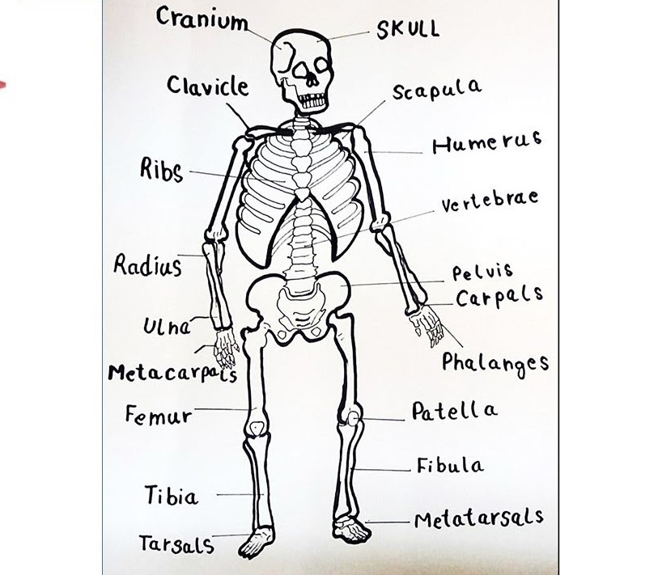

Note:- Prepare children’s for TERM IST Examination

THANK YOU

