ASSIGNMENT FOR TERM IST
Class: - 6th Subject: - Science
Session: - 2019-2020
Topic:-Separation Of Substances.
Q1. What is a Pure-substance?
Ans. A pure substance is a substance which is made up of only one kind of particles.
Examples: - 1. Element- O, N 2. Compound – H₂O.
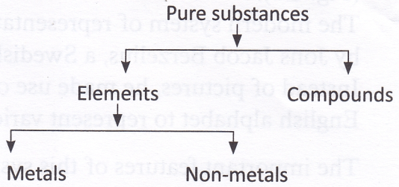
Q2. What is a Mixture? Give example.
Ans. A mixture is a substance formed by mixing various types of substance together. E.g , Air.

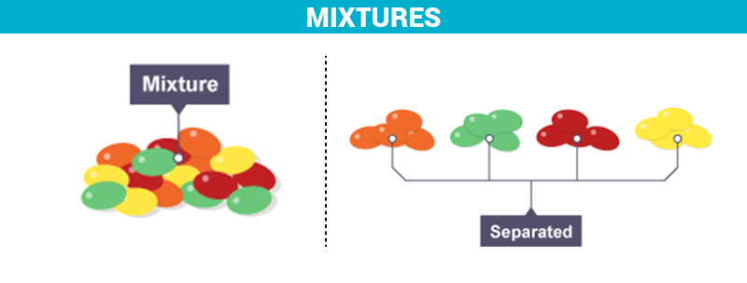

Q3. Name the various types of mixture?
Ans A mixture is of two types:-
- Homogenous mixture: - Are those which have uniform composition e.g Sugar and water.
- Heterogeneous mixture: - Are those which don’t have a uniform composition e.g Sand and water.
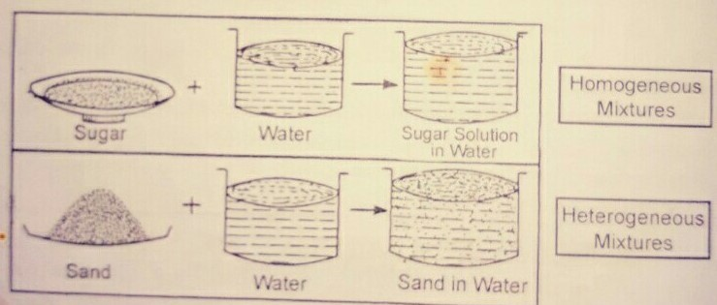

Q4. Why do we need to separate substances?
Ans we need to separate substances like mixtures into its components. The need may be:-
- To separate Butter from Milk by churning milk.
- To obtain the desirable substance(separate tea leaves from brewed tea)
- To remove impurities from substance. (Clean water by removing mud).

Q5. Name the substance used in Loading. How does it help?
Ans. The substance used in loading is Alum. It makes the suspended particle of the mixture heavy, as a result the particle settle down faster, this process is called Loading

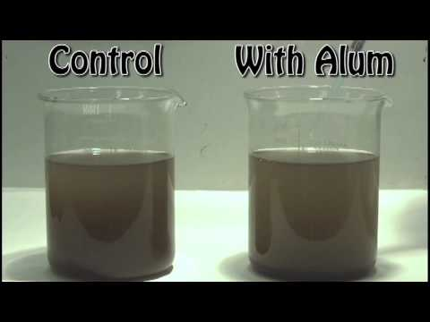

Q6. How are pure substances different from mixtures?
Ans. Pure-substance: - Is made up of only one kind of particles Examples-Gold, Silver and mercury or oxygen.
Mixtures: - Are made up of two or many kinds of particles Examples – Air. As Air is the mixture of carbon, oxygen, Hydrogen, Nitrogen, Water vapours etc.
Q7. Define the following terms:-
- Impurities: - It is a waste material which should be removed e.g, when we prepare a tea it is filtered by a sieve. The waste material remains on it which should be removed.
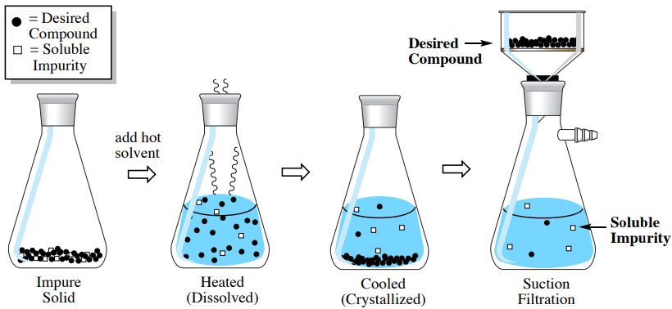
- Solute:- It is a solid substance like salt and sugar which dissolves in water.
- Solvent:- It is a liquid substance like water which dissolves the solute.
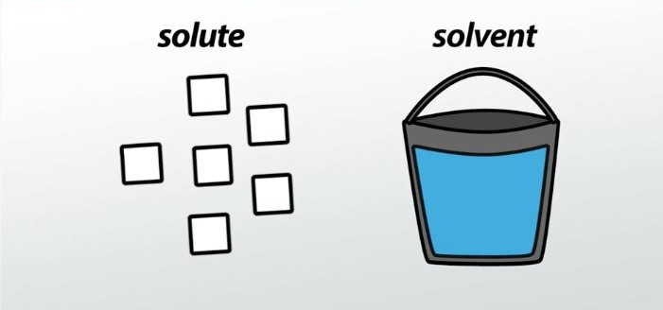

- Solution:- When solvent dissolves solute Water + salt = salt solution. It forms the solution of salt water.

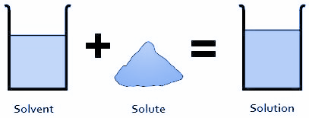

- Saturated solution:- A solution which is not capable of dissolving the . solute any more at a given temperature is called a . saturated solution.

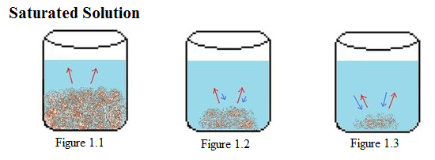
Q8. Short Answer Type Question:-
Q1. Which type of mixture is obtained when we mix ink with water?
Ans. The mixture which is obtained when we mix ink with water is Miscible liquid.
Q2. Name one way to remove insoluble-particles from a solid-liquid-mixture?
Ans. Insoluble particles are removed from a solid-liquid mixtures are made to settle down is called sedimentation.
Q3. What kind of mixture is an aerated drink?
Ans. It is liquid-gas-mixture as carbon dioxide is mixed in water under pressure like soda-water is Aerated drink.
Q4.Which method is used to enhance the process of sedimentation?
Ans. Loading is the method used to enhance the process of sedimentation.
Q5. During which method of separation does the simultaneous process of evaporation and condensation take place?
Ans. The simultaneous process of evaporation and condensation, condensation takes place by process of distillation.
Q9. Give the examples of each:-
- Miscible liquids – E.g, Milk & water.
- Immiscible liquids – E.g, Oil & water.
- Soluble mixture – E.g, Water, salt & sugar.
- Insoluble mixture – E.g, Water, sand & salt.
- Homogenous mixture – salt & water
- Heterogenous mixture – Sand & water.
Q10. Choose one word to make the sentence true and underline that word:-
- Sublimation/ Filtration is the process by which insoluble solids &liquids are separated.
- Homogenous / Heterogenous do not have uniform composition.
- Solute & solvent mix together to form sediments / solution.
- Solid that remains on the filter paper in the process of filtration is called residue /distillate.
- Solute in salt solution is the salt/water
Q11. Choose the correct option in each and make that word bold:-
- You can dry vegetables curry by the process of:-
- Distilation b) Evaporation
- A sieve can be used to separate:-
- Milk from Water.
- Tea leaves from tea.
- Distillation is the process of simultaneous:-
- Heating & cooling
- Evaporation & condensation.
- Solute &solvent mix together to form:-
- Mixture b) Solution
- Threshing separates:-
- Seeds from stalk b) Husk from rice.
Note:- prepare all these Assignments for TERM IST Exams.
THANK YOU

