ASSIGNMENT FOR TERM IST
Class: - 6th Subject: - Science
Session: - 2019-2020

TOPIC: - CLOTH MATERIAL
Q1. What is Fabrics?
Ans. All clothes are made up of fabrics. These fabrics are made up of various fabrics like cotton, wool, silk and synthetics etc.

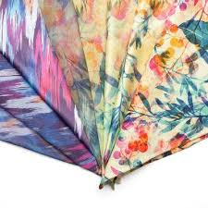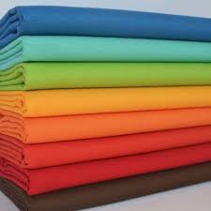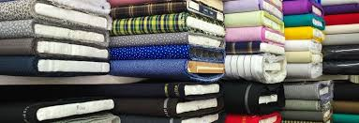

Q2. Define the various types of fibres?
Ans. Fibres are of two types:-
- Natural Fibres:- These fibres are obtained from plants and animals like cotton , jute and flex from plants. Wool and silk is obtained from animals.
Diagram of Natural Fibre:-

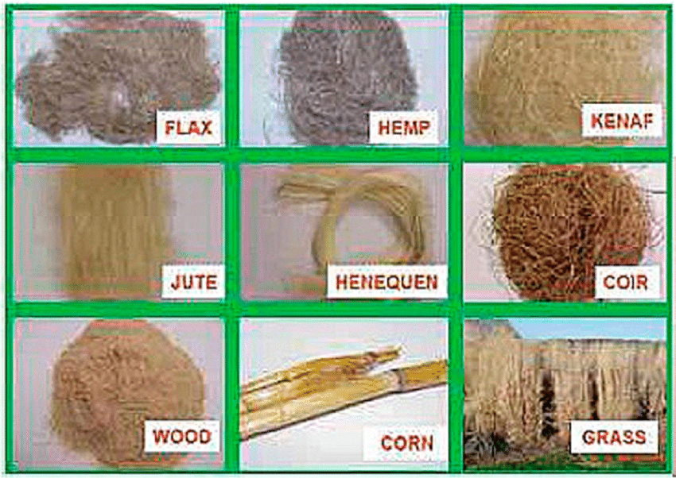

- Synthetic Fibres:- These fibres are obtained from chemical in factor like Nylon, Rayon, polyester and terylen are some artificial fibres.

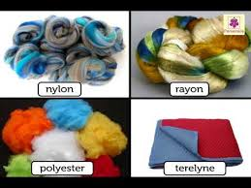

Q3.Give the importance of Natural and (artificial or) Synthetic cloth?
Ans. COTTON CLOTH:-
- It is light and porous cloth.
- It absorbs sweat and used in summer.
- It is durable cloth.
- It is costlier.
SYNTHETIC CLOTH:-
- It is light cloth and cheaper
- It is not porous but water-repelling
- Being synthetic it can’t absorb sweat. It is Elastic.
- It is long lasting, strong and durable cloth.
Q4. What is Flax?
Ans. Flax is plant-fibre. It is obtained from the stalk of flax plant. Flax-fibre are woven to make a fabric called linen. It is used for making ropes and paper.
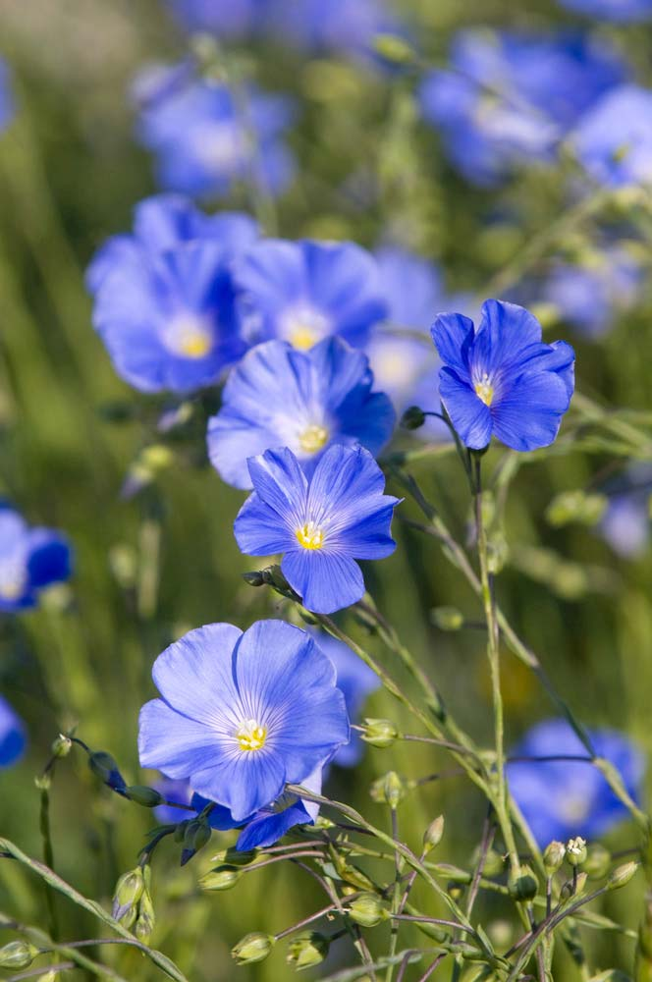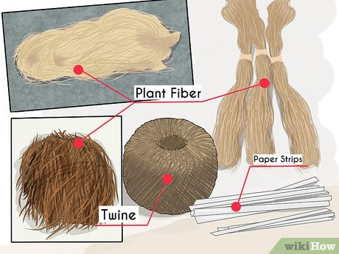

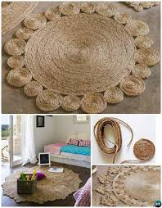

Q5. Define these terms:-
- Spinning 2. Combing 3. Retting
- Spinning: - It is the method of making yarn.
- Combing: - Cotton-fibre is removed from the seeds by combing method.
- Retting: - Soaking of jute stems in water is called retting.
Q6. How are jute and cotton different?
JUTE: - Is cultivated in clayey-soil in coastal areas. It grows in warm and humid climate. Its fibre is durable and strong. Its ropes are used in chairs, tables and stools.
COTTON: - It is cultivated in black soil. It grows well in warm climate. Its fibres are called yarn. Which are used in making cotton clothes.
Q7. Why do we prefer to wear synthetic clothes in rainy season?
Ans. We prefer to wear synthetic clothes in rainy season because:-
- It is light and Non-porous cloth.
- It is cheaper and elastic.
- Synthetic clothes are long lasting strong.
- They are water-repelling.
Q8. Why do we prefer to wear cotton-clothes during summer?
Ans. We prefer to wear cotton clothes in summer because:-
- It is light and porous cloth.
- It is durable.
- It is costlies then synthetic.
- It absorbs sweat that is why we wear it in summer.
Q9. What did early people wear?
Ans. Early people covered their bodies with leaves, barks of trees and animal skins etc.
Q10. One of the important steps in processing jute is retting? Explain.
Ans. After harvesting jute, the root and foliage are removed. The stems are tied in bundles and soaked in water for about 15 days. This soaking of stem is called retting.
Q11. Which of the fabric, synthetic or cotton has a longer life and why?
Ans. Synthetic fabric has a longer life because:-
- They are strong, water – repelling elastic, light weight.
B. Short Answer Type Questions:-
Q1. What are the fine threads in a cloth called?
Ans. The fine threads like a structure of natural and synthetic material are called
Fibres.
Q2. Name the hand operating device used for spinning?
Ans. The hand operating device used for spinning is:-
Spinning is: - spinning wheel or charkha.
Q3. Name the synthetic fibre which is used to make ropes?
Ans. Polyester and nylon fibre are used.
Q4. Name the process in which two sets of yarns are arranged to make a fabric?
Ans. The process is known as weaving.
Q5. Which soil is best suited for hemp plant?
Ans. The soil which is best for hemp plant is loamy soil.
C. Complete the given analogies:-
1. Silk : Sericulture :: Wool : Shearing
2. Black soil : Cotton :: Clayey soil : jute.
3. Silk Cotton: plant origin :: silk : Animal origin
4. Jute: retting :: Cotton : weaving
5. Coir: coconut :: Silk Cotton : plant.

D. Change one word to make sentence tree.
1. Wool is rough and tough
Jute is rough and tough.
- Rearing of silkworm to get silk is called shearing. Sericulture.
- Soaking of stem is called spinning is called retting.
- Flax-fibres are woven to make a fabric called nylon. Called linen.
E. Choose correct reasons for each and underline the correct answer.
1. Jute is cultivated in coastal areas.
a) Jute grows in salty water.
b) Warm and humid climate.
2. Kapok is used in making life jacket.
a) It is obtained from hemp plant.
b) It is light and fluffy.
3. Jute fibers are dipped in water so that:-
a) Fibers absorb water to separate.
b) Fibers absorb water and stick.
F. Answer in one word:-
1. It is a process of changing yarn into fabric. Spinning
2. It is a process in which single yarn is converted to a piece of fabric is Knitting
3. It is process of interweaving three or more strands of yarn is Braiding
4. A small piece of cloth is burnt
a) If it smells like burning paper, it is Cotton
b) If it burns leaving black mass, it is Synthetic
G. Fill in the blanks:-
1. Twisted bundle of fiber Yarns.
2. Silk is get from Cocoon of silk worm

3. Wool is obtained from Sheep
4. Nylon is example of synthetic fiber.
5. Coir is obtained from the husk of Coconut.
6. Method of making yarns is called Spinning.
7. Ginning is process of removing.
8. Soaking of jute stem in water is called Relling.
9. Cotton grows in Black soil.
10. Fiber of jute is Durable and Strong.

Note:- Prepare all these for TERM IST Examination.

THANK YOU

