SUBJECT:EVS
TOPIC:SENSEORGANS

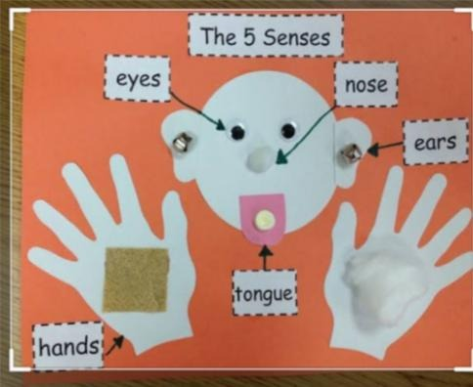

I CAN SEE WITH MY EYES.

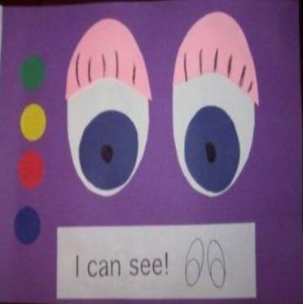

I CAN TASTE WITH MY TOUNGE.

I CAN HEAR WITH MY EARS.

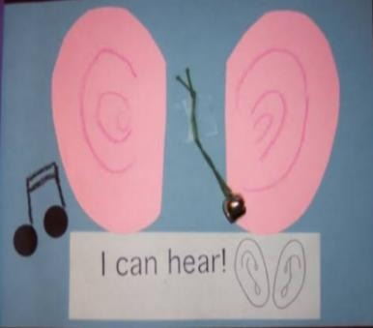

I CAN SMELL WITH MY NOSE

I CAN FEEL WITH MY SKIN.

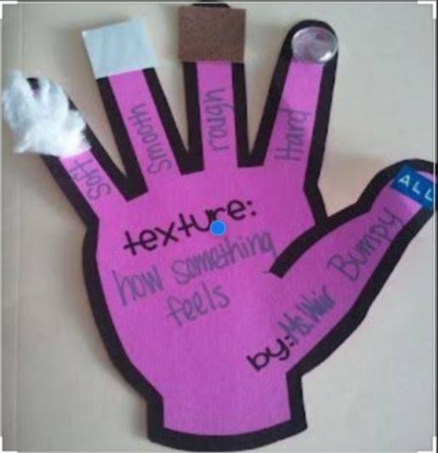

LET'S RECAPITULATE.
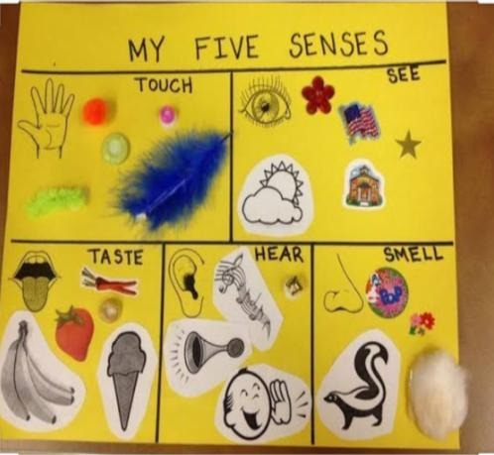

THANK YOU
Note:- Try to learn these sense organs to your kids.

