**Kashmir University Model High School**

**University of Kashmir, Srinagar.**

NAAC Accredited Grade – A+

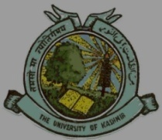Naseem Bagh Campus Hazratbal, Srinagar.

**Date sheet for Golden Test class 10th**

**Session December 2024**

|  |  |
| --- | --- |
| Date | Subject |
| 05-12-24 | Maths |
| 07-12-24 | Urdu |
| 09-12-24 | Disaster management / Geography |
| 11-12-2024 | English |
| 13-12-2024 | Physics/ Chemistry |
| 16-12-2024 | Biology |
| 18-12-2024 | History /Civics |

Note:

1. Parents are requested to clear all dues before 1st December 2024 (Tuition fee / Bus fare).
2. Examination will start at 11:00 am, and on Friday at 10:30 am.
3. No student will be allowed to borrow things like pen, pencil, eraser etc from fellow student.
4. No re-examination shall be conducted if a student remains absent on any exam day.
5. Date of result shall be communicated separately.

Sd/

Headmistress

KUMHS