ASSIGNMENT FOR CLASS 4th
Session 2019-2020
Topic:- Digestion.
Q1. what is digestion? What are its organs?
Ans. Digestion is the process by which complex food stuffs are changed into simpler one by the action of enzymes.
ORGANS OF DIGESTION
The organs involved in Digestion are :-
1. Mouth 2. Food pipe(esophagus) 3. Stomach 4. Liver 5.Small intestine
6. Large intestine 7. Rectum 8. anus.
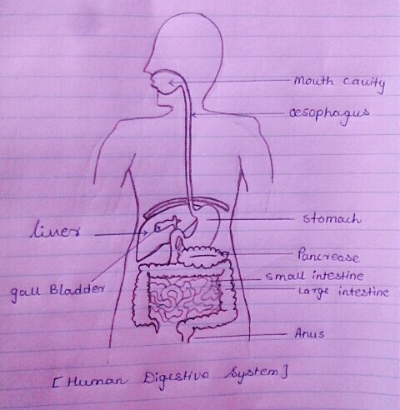

Q2.Write down symbols of following elements?
Ans. ELEMENTS SYMBOLS
1. Carbon C
2. Oxygen O
3. Hydrogen H
4. Chlorine Cl
5. Flourine F
6. Calcium Ca
7. Sodium Na
8. Mercury Hg
9. Silver Fe
10. Gold Au
Q3. What is Filtration?
Ans. The process by which we can separate impurities from a liquid e.g, filtration
of water etc.
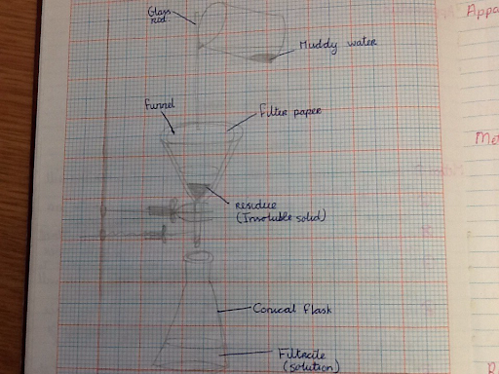

Q4. What is a flame? name the zones of flame.
Ans. Burning part of a candle is called a flame. A flame has four zones.
1. Luminous Zone
2. Non- Luminous Zone
3. Dark inner zone.
4. Blue Zone.

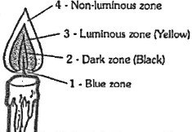

Q5. How many bones Upper limb has ? Name them.
Ans. Upper limb has 33 bones and these are:-
1. Collar Bone 2. Shoulder Bone 3 Humerus 4. Radius
5. Ulna 6. Eight-Carpals 7. Five- Meta carpals
8.Fourteen Phallanges.

