HOME ASSIGNMENT
Class 4th
Q1. What do you mean by Garbage?
Ans:- Materials that are no longer needed and are thrown away is called garbage. Garbage creates foul smell.
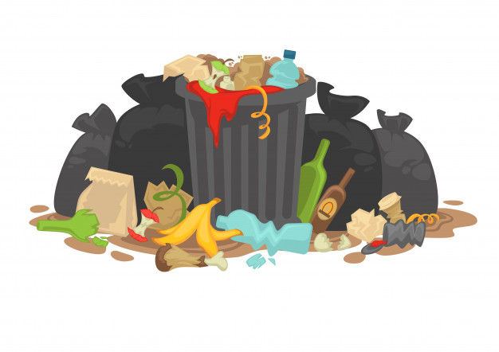
Q2. What do you mean by recyclable waste?
Ans:- Recyclable waste is such waste which is converted into raw materials and then new products are made from it.
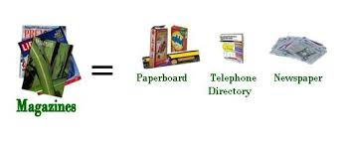
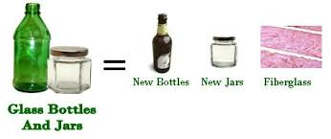

Q3. What is a dumping site?
Ans: - A dumping site is a barren land where garbage is dumped.
Q4. Write the different ways of disposing wastes?
Ans: - Different ways of disposing wastes are:-
- Open Dumping:- In this process, waste is thrown in the open to decompose. It reacts with air, water and sunlight, but this method is very harmful.
- Sanitary land filling: - In this method deep pits are dug outside the cities. These pits are called landfills. The waste decomposes in the pits and becomes a part of the soil.
- Incineration:- When waste is burnt in big furnaces , it is called incineration. It causes air pollution due to release of smoke and heat.
Q5. What do you mean by Bio-degradable wastes?
Ans: - Bio-degradable waste is such waste which can be decomposed by soil bacteria. For example, vegetables and fruit peels, egg shells etc.
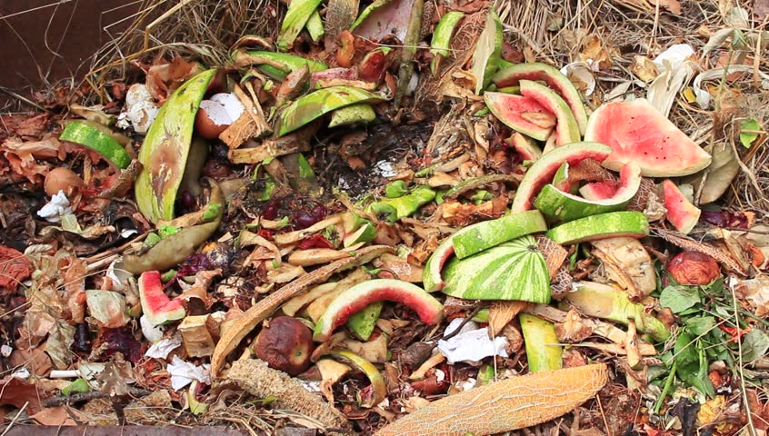
Q6. What do you mean by Non-Biodegradable?
Ans. Non-Biodegradable waste is such a waste which cannot be decomposed by soil bacteria. For example, metal foils polythene, etc.
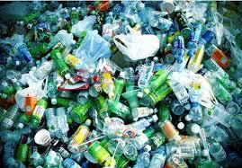

ATLAS
Q1. Major Rivers of the world?
Ans:- Major Rivers of the world are:-
- Nile 2. Amazon 3. Ganges 4. Mississippi River
5 Yangtza 6. Mekong River 7. Volga River.
Q2. Major Mountains of the world?
Ans:- Major Mountains of the world are:-
- Mount Everest 2. Mount Blanc 3. Mount Elbert 4. Joubkal
Q3. Write Agricultural products of India?
Ans:- Agricultural products of India are:-
- Rice 2. Milk 3. Buffalo meat 4. Wheat 5. Mango
6. Saffron 7 Cotton 8. Walnuts 9. Spices.

