HOME ASSIGNMENT 2
Class:- 4th
Q1. Explain the different positions of the tongue that are sensitive to the different tastes?
Ans: - Different positions of the tongue are sensitive to different tastes. The taste buds near the tip of the tongue tell us whether the food is salty or sweet. At the back of the tongue, taste buds for bitter taste are suited .Buds situated on the sides of the tongue help us to identify sour taste.
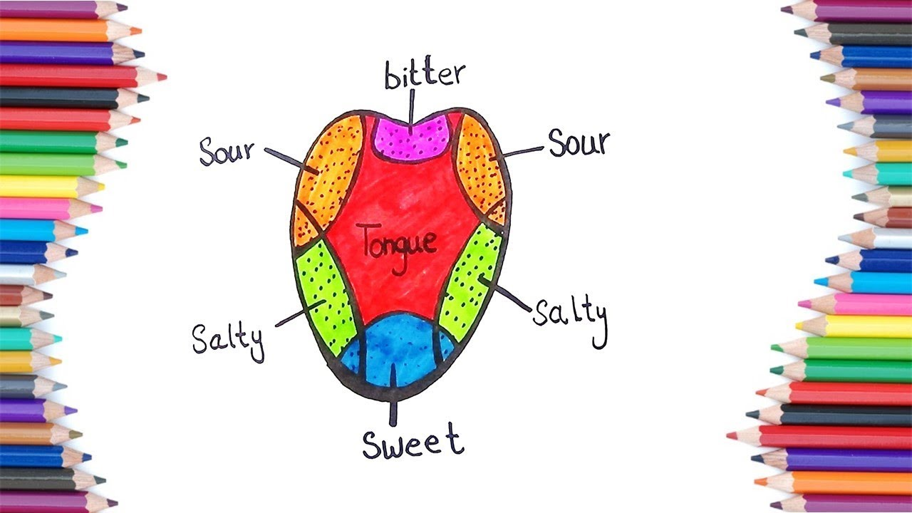

Q2. Explain the structure of teeth?
Ans: - Teeth are hard, bony structures firmly fixed in the upper and lower jaws. Our teeth grow out from the soft pink gums. Crown is the visible part of the teeth. It is the portion of the tooth above the gum. The White enamel that covers the teeth is the strongest substance in the body. The portion of the tooth inside the gum is called the root. Root is the anchor of a tooth that extends into the jawbone. The next layer is of the dentine. It is the main part of the tooth. The Centre of each tooth is called pulp. It has blood vessels and nerves in it.

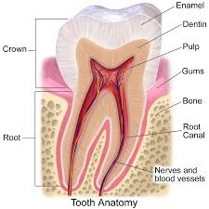
Q3. Explain the different kinds of teeth with their work?

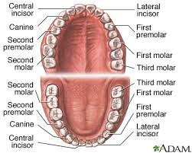
Now we can below define different kinds of teeth and their work.
Ans: - Different kinds of teeth are:-
- Incisors:- These are the four front teeth in each jaw. Their total number is eight. They have sharp straight edges. They are used for cutting and biting food. So, they are also called cutting teeth.
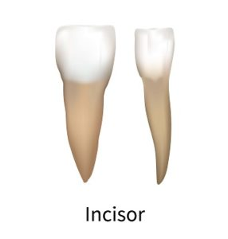

- Canines: - Each jaw has two canines. Their total number is four. They are very sharp and pointed. They are present on either side of the incisors in each jaw. They help us in tearing the food. So, they are called tearing teeth.

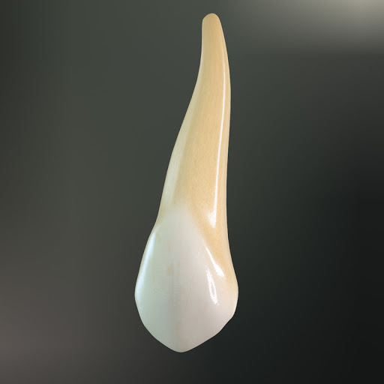

- Premolars:- These are next to canines. There are four premolars in each jaw. They are broad and flat. They help us in cracking and crushing the food like nut crackers. So, they are called cracking teeth.
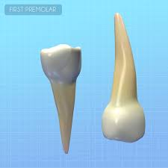
- Molars: - There are six molars in each jaw making a total of 12. These are next to premolars. Molars are broader than pre-molars. They help us in grinding teeth.
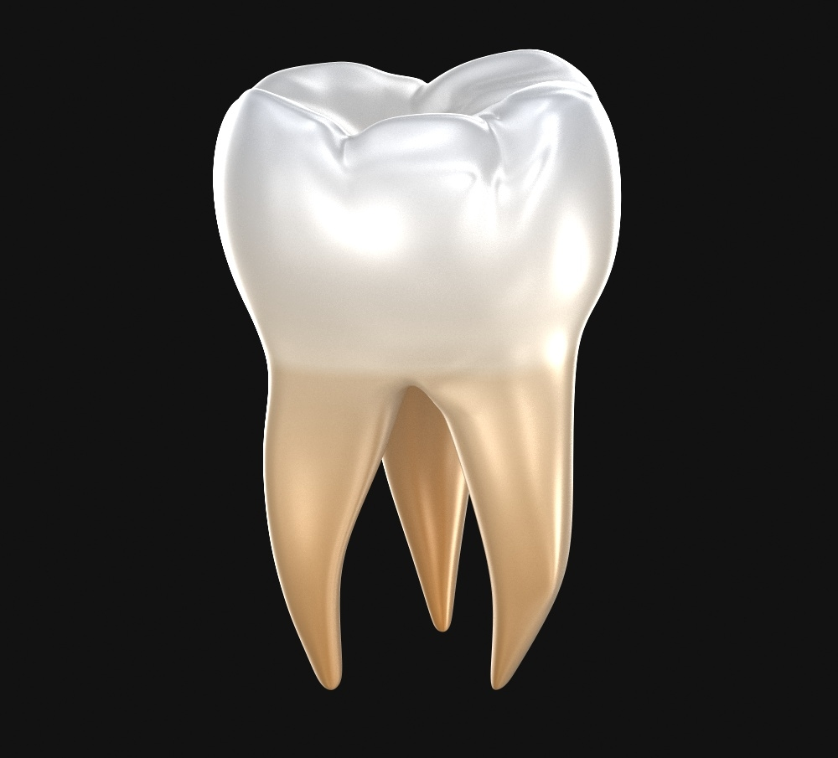
Q4. Why should we take care of our teeth?
Ans: - Teeth are an important part of our body. We must take care of our teeth properly. We should brush our teeth in morning and night regularly. When we do not brush our teeth properly, bacteria collect in the mouth and keep multiplying. Bacteria can erode the white enamel of the tooth and form holes or cavities.
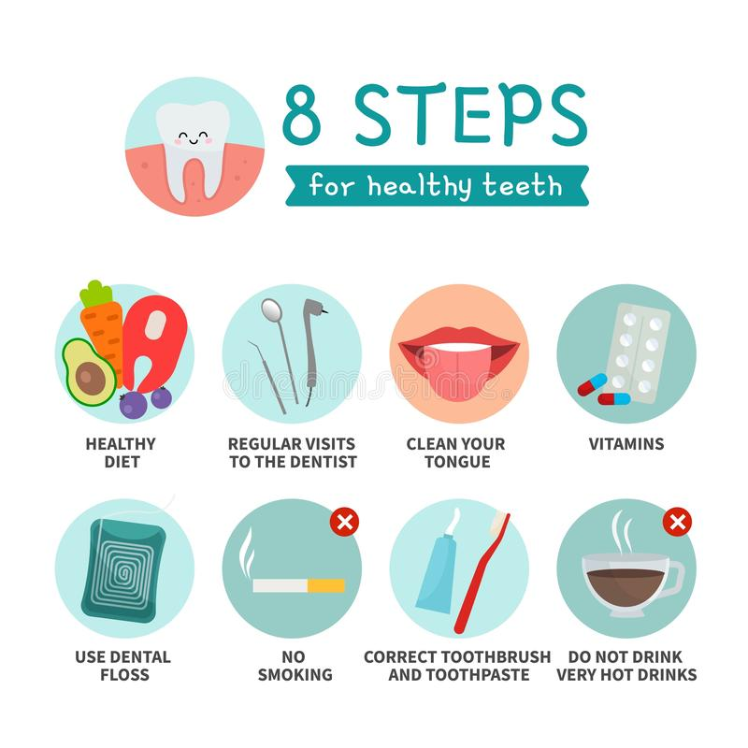
Q5. Explain the other functions of the tongue?
Ans: - Our tongue helps us to swallow the food. It pushes the chewed food into the food pipe. We cannot speak without using our tongue. So, we should take due care of our tongue.
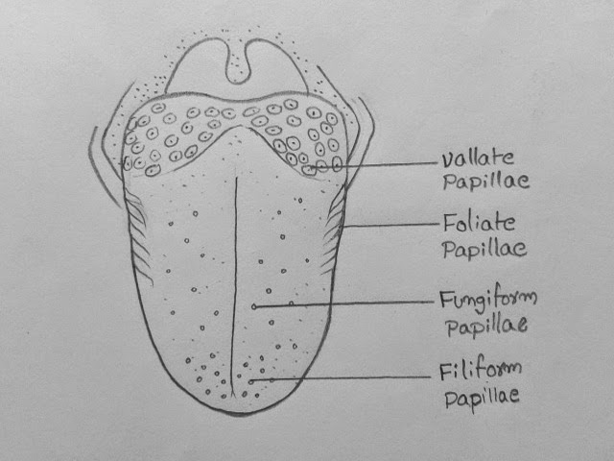
NOTE:- Write all these Questions / Answers of Assignment 1st and 2nd on your Evs notebook.

